 | Lesson Title: Mixing it up while keeping it pure (Particle Theory of Matter) | Grade: 7 Cluster: 2  SLO 7-2-13 and 7-12-14

 | Teaching – Learning Sequence | Materials Required
Cluster 0: Scientific Inquiry  Initiating, Researching & Planning  7-0-1A. Formulate specific questions that lead to investigations. Develop questions based on students finding using the sugar and water observation.  7-0-3A. Formulate a prediction/hypothesis that identifies a cause and effect relationship between the mixture of sugar and water and what they think will happen when combined.  Implementing; Observing, Measuring &  Recording  7-0-4D. Assume various roles to achieve group goals during the observation stage of the activity.  7-0-5a . Make observations that are relevant to a specific question when students explore how sugar and water particles behave when mixed and separate and determine the reason for the findings.  Analysing & Interpreting  7-0-6B. Interpret pattern and trends in data, and infer and explain relationships. Students use the data collected in the activity to make connections for how mixtures are created and what characteristics they have.  Concluding & Applying  7-0-7f . Reflect on prior knowledge and experiences to construct new understanding and apply this new knowledge in other contexts. Students use the knowledge gained in the previous exploration to justify reasons for their findings using agreed upon characteristics.  Reflecting on Science and Technology  7-0-8B. Describe examples of how scientific knowledge has evolved in light of new evidence, and the role of technology in this evolution. Seen in the use of microscopes to see particles that are too small to see with the naked eye. | Begin the lesson by talking about matter.  - What is matter? Everything is made up of matter, or tiny particles. Show a model of matter (Styrofoam might be a good example to illustrate that the block of Styrofoam is made up of smaller particles, like matter)  - There a couple of rules taken from the Particle Theory of Matter that we need to remember when talking about pure substances and mixtures:  - All matter is made up of extremely tiny particles.  - Each pure substance has its own kind of particle, different from the particles of other substances.  In terms of pure substances and mixtures, we need to review what a pure substance and mixtures are. (Use the Venn diagram and student answers to develop a cohesive definition of both).  Make sure students understand that in pure substances the tiny particles are exactly the same.  - Provide an example of distilled water and tap water. Distilled water goes through a process where the minerals are removed so that the distilled water contains only H2O particles (which make it a pure substance)  - Tap water contains minerals and other particles that make it a mixture.  - Have students illustrate example below:  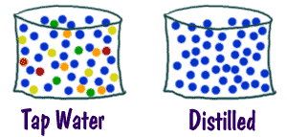  Now say that we will be exploring the idea of mixtures in more detail. Mixtures occur almost everywhere, but there are differences between types of mixtures.  There are an infinite number of mixtures. Anything you can combine is a mixture. Think of everything you eat. Just think about how many cakes there are. Each of those cakes are made up of a different mixture of ingredients. Even the wood in your pencil is considered a chemical mixture. There is the basic cellulose of the wood, but there are also thousands of other compounds in that pencil.  The students will participate in an activity to explore mixtures.  (Student handout attached) | Teacher materials:  Overhead projector  Student handouts  Cups and plates for samples  Distilled water  Sugar  Cups or beakers  Student materials:  Science journals  Pen/pencil  Safety considerations:  This experiment requires the use of a variety of materials and substances. Students should be made aware of how to conduct themselves responsibly when touching and observing the items. The items should not be eaten in in science class or spilled on the floor to avoid messes.  Reference:  Manitoba Education and Training. (2000). Grade 7, Cluster 2 Particle theory of matter. A foundation for implementation. Government of Manitoba.  Sciencepower 7 (Sections 4.1-4.2)
STSE Issues/ Design Process/ Decision Making:  C8. evaluate, from a scientific perspective, information and ideas encountered during investigations and in daily life  E1. describe and appreciate the similarity and diversity of forms, functions, and patterns within the natural and constructed world  Essential Science Knowledge Summary  D3. understand the properties and structures of matter as well as various common manifestations and applications of the actions and interactions of matter  In this lesson students will be taught that:  A homogeneous mixture is made up of two or more substances where the properties of each remain intake and separate. Where the particles of each are distributed evenly. Examples include: brass, sterling silver, salt water, air.  That liquid mixtures contain particles, just like solids and gases.  Will you assess? YES If so, what?  I will assess the students on the completion of their tables and the answers they provide in the student handout about mixtures.  How will you assess it?  I will take in the journals and review the students answers to the questions to determine if I was clear in my explanations and if more emphasis needs to be provided in the area of mixtures. | Once the students have completed the activity I will show them how what they explored would be considered a homogeneous mixture, or solution.  Leading questions after the activity  What were the pure substances  What was the mixture?  If you took the water away would you be able to get the sugar back in its original form.?  In the experiment, the students explored how two pure substances, when combined created a mixture. This mixture is considered a solution because when the sugar and water(pure substances) are combined, the sugar particles remain sugar particles and the water particles remain water particles. The solution has both sets of properties.  If possible have the students view the homogeneous mixture using a microscope or have the image displayed on a screen. The screen should show that the sugar and water particles remain separate and scattered evenly throughout the solution with no visible clumping of particles as seen in a mechanical mixture. (Mechanical Mixtures are to be discussed in a later class)  Have the students write the definitions they will need in their science journals  Homogeneous mixture: A homogenous mixture is made up of two or more substances and where the particles of each are distributed evenly. Examples include: brass, sterling silver, salt water, air.  In the next class the students will explore some other examples of homogeneous mixtures. They will also learn more about what a heterogeneous mixture is  Image of a homogeneous mixture to be displayed for students:  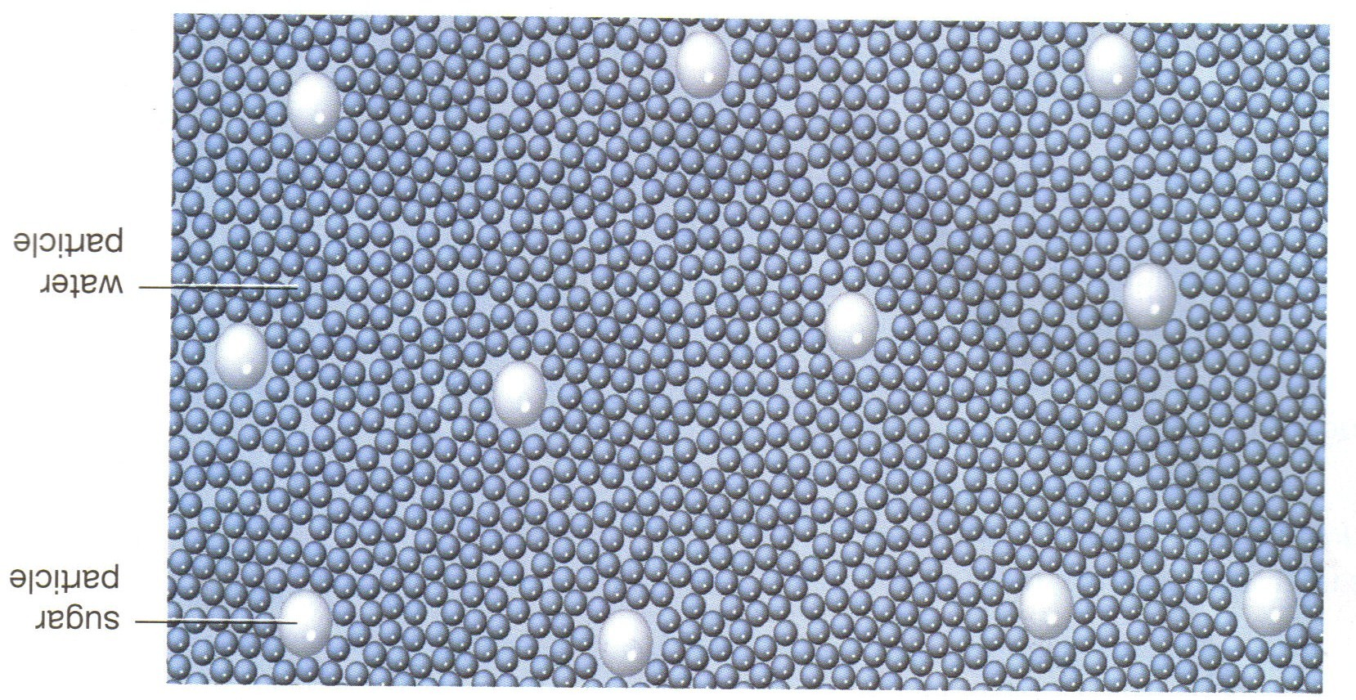 | Questions to consider in your planning / delivery:  - Does the lesson start through engagement?  No, the lesson starts with teacher lead explanations and review of the terms from the last class.  - Am I using this phase as an opportunity to find out where students are ‘at’ in their thinking? I am using this phase to provide students with a deeper understanding of a mixture and how mixtures are produced so that they can participate in the next portion of the lesson.  - Is there an emphasis on first-hand experiences – an evidential phase?  The students will participate in an activity for them to better understand how mixtures can be made from two pure substances. They will find evidence in their finding by hopefully being able to see the microscopic image of the sugar and water image.  - Am I helping students to make sense of these experiences – a psychological phase?  Yes. I am explaining how their findings show how mixtures are derived and what they look like at a level that they cannot see by sight alone.  - Is there a theoretical phase where the essential science knowledge is articulated and consolidated? Yes. The information is consolidated at the end of the lesson from the activity questions and my explanation.  - What specific skill and knowledge development am I emphasizing?  I am developing student skills in experimentation and understanding that there is a difference between substances even if we cannot see the difference.  - Is there evidence of clear instructions and purposeful questions in my teaching sequence? Yes. Questions are used to direct student learning but are not intended to answer the questions for them. Teacher will emphasis using visuals.

